***Technical Manual for Dimension Calculator***

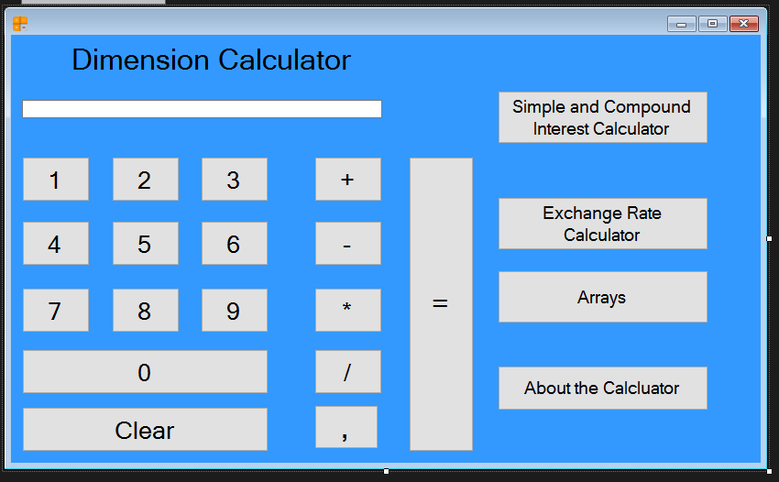

***Basic calculator code***

using System;

using System.Collections.Generic;

using System.ComponentModel;

using System.Data;

using System.Drawing;

using System.Linq;

using System.Text;

using System.Threading.Tasks;

using System.Windows.Forms;

namespace WindowsFormsApplication1

{

public partial class Calculator : Form

{

//static bool ClearText;

string operand1 = string.Empty;

string operand2 = string.Empty;

string result;

char operation;

public Calculator()

{

InitializeComponent();

}

private void Calculator_Load(object sender, EventArgs e)

{

}

private void button1_Number1_Click(object sender, EventArgs e)

{

//This is the Button variable

Button b = (Button)sender;

//The b instance will then transfer it to text so that it can be displayed on the textbox

//The plus in front of the equal sign will make sure that you can create double digits etc

textBox1.Text += b.Text;

}

private void button2_Number2_Click(object sender, EventArgs e)

{

//This is the Button variable

Button c = (Button)sender;

//The b instance will then transfer it to text so that it can be displayed on the textbox

textBox1.Text += c.Text;

}

private void button3_Number3_Click(object sender, EventArgs e)

{

//This is the Button variable

Button d = (Button)sender;

//The b instance will then transfer it to text so that it can be displayed on the textbox

textBox1.Text += d.Text;

}

private void button4_Number4_Click(object sender, EventArgs e)

{

//This is the Button variable

Button d= (Button)sender;

//The b instance will then transfer it to text so that it can be displayed on the textbox

textBox1.Text += d.Text;

}

private void button5_Number5_Click(object sender, EventArgs e)

{

//This is the Button variable

Button b = (Button)sender;

//The b instance will then transfer it to text so that it can be displayed on the textbox

textBox1.Text += b.Text;

}

private void button6_Number6_Click(object sender, EventArgs e)

{

//This is the Button variable

Button b = (Button)sender;

//The b instance will then transfer it to text so that it can be displayed on the textbox

textBox1.Text += b.Text;

}

private void button7_Number7_Click(object sender, EventArgs e)

{

//This is the Button variable

Button b = (Button)sender;

//The b instance will then transfer it to text so that it can be displayed on the textbox

textBox1.Text += b.Text;

}

private void button8_Number8_Click(object sender, EventArgs e)

{

//This is the Button variable

Button b = (Button)sender;

//The b instance will then transfer it to text so that it can be displayed on the textbox

textBox1.Text += b.Text;

}

private void button9_Number9_Click(object sender, EventArgs e)

{

//This is the Button variable

Button b = (Button)sender;

//The b instance will then transfer it to text so that it can be displayed on the textbox

textBox1.Text += b.Text;

}

private void button15_Number0_Click(object sender, EventArgs e)

{

//This is the Button variable

Button b = (Button)sender;

//The b instance will then transfer it to text so that it can be displayed on the textbox

textBox1.Text += b.Text;

}

private void button10_Clear_Click(object sender, EventArgs e)

{

Button clear = (Button)sender;

//This will return an empty string that will be displayd on the textbox

textBox1.Text = "";

}

private void textBox1_TextChanged(object sender, EventArgs e)

{

}

private void button11_Plus_Click(object sender, EventArgs e)

{

operand1 = textBox1.Text;

operation = '+';

textBox1.Text = string.Empty;

}

private void button1_Click(object sender, EventArgs e)

{

//operand two will display the end result of any case statement in the textbox

operand2 = textBox1.Text;

//declaring variables op1 and op2 so that we can use them in the switch statement

//string dot = ",";

double op1;

double op2;

//Converting the above-mentioned variables to the global variables we created

double.TryParse(operand1, out op1);

double.TryParse(operand2, out op2);

switch (operation)

{

case '+':

result = (op1 + op2).ToString();

//result = (op1 + "." + op2).ToString();

//result = (op1 + op2 + ".").ToString();

break;

case '-':

result = (op1 - op2).ToString();

break;

case '*':

result = (op1 * op2).ToString();

break;

case '/':

if (op2!=0)

{

result = (op1 / op2).ToString();

}

else

{

MessageBox.Show("Can't divide by zero");

}

//The code below casts the object

break;

default:

break;

}

textBox1.Text = result.ToString();

}

private void button12_Minus_Click(object sender, EventArgs e)

{

operand1 = textBox1.Text;

operation = '-';

textBox1.Text = string.Empty;

//The code below casts the object

Button btn = sender as Button;

if (btn.Text == ",")

{

if (!textBox1.Text.Contains(","))

{

textBox1.Text = textBox1.Text + btn.Text;

}

else

{

textBox1.Text = textBox1.Text + btn.Text;

}

}

}

private void button13_Multiply_Click(object sender, EventArgs e)

{

operand1 = textBox1.Text;

operation = '*';

textBox1.Text =string.Empty;

}

private void button14_Division_Click(object sender, EventArgs e)

{

operand1 = textBox1.Text;

operation = '/';

textBox1.Text = string.Empty;

}

private void button2_Click(object sender, EventArgs e)

{

Button a = (Button)sender;

textBox1.Text += a.Text;

}

private void button1_InterestCalculator_Click(object sender, EventArgs e)

{

SimpleInterestCalculator simple = new SimpleInterestCalculator();

simple.Show();

}

private void button2_ExchangeRateCalculator_Click(object sender, EventArgs e)

{

CurrencyCon curreny = new CurrencyCon();

curreny.Show();

}

private void button3_Click(object sender, EventArgs e)

{

AboutCalculator about = new AboutCalculator();

about.Show();

}

private void label1_Click(object sender, EventArgs e)

{

}

}

}

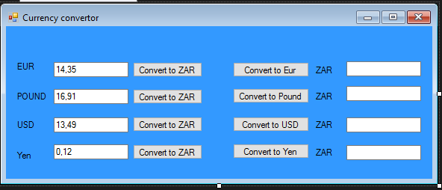

*Currency convertor code*

using System;

using System.Collections.Generic;

using System.Linq;

using System.Text;

using System.Threading.Tasks;

namespace WindowsFormsApplication1

{

class CExchange

{

//Declaring global variables to be mentioned in the code that follows

private double numtobecounted;

private double usdzar;

private double eurzar;

private double poundzar;

private double yenzar;

private double zarusd;

private double zarpound;

private double zaryen;

private double zareur;

//Creaing a constructor

public CExchange()

{

//defining the global variables in the constructor

double nmbtc=numtobecounted;

usdzar = 13.49;

eurzar = 14.35;

poundzar = 16.91;

yenzar = 0.12;

zarusd = 0.075;

zarpound = 0.059;

zaryen = 8.09;

zareur = 0.071;

}

//creating a property to ensure so that the object instantated can can have validateed values

public double NumtoBecounted{ get; set; }

//The next four methods are for the conversions created from foreign exchange to the rand

public double Conversion1(double numtobecounted)

{

double convert = numtobecounted * usdzar;

return convert;

}

public double Conversion2(double numtobecounted)

{

double convert2 = numtobecounted * eurzar;

return convert2;

}

public double Conversion3(double numtobecounted)

{

double convert3 = numtobecounted * poundzar;

return convert3;

}

public double Conversion4(double numtobecounted)

{

double convert4 = numtobecounted * yenzar;

return convert4;

}

//The next four methods are for the conversion from rand to foreign currency

public double Inversion1zareur(double numtobecounted)

{

double invert1 = zareur * numtobecounted;

return invert1;

}

public double Inversion2zarusd(double numtobecounted)

{

double invert2 = zarusd * numtobecounted;

return invert2;

}

public double Inversion3zarpound(double numtobecounted)

{

double invert3 = numtobecounted * zarpound;

return invert3;

}

public double Inversion4zaryen(double numtobecounted)

{

double invert4 = numtobecounted * zaryen;

return invert4;

}

}

}

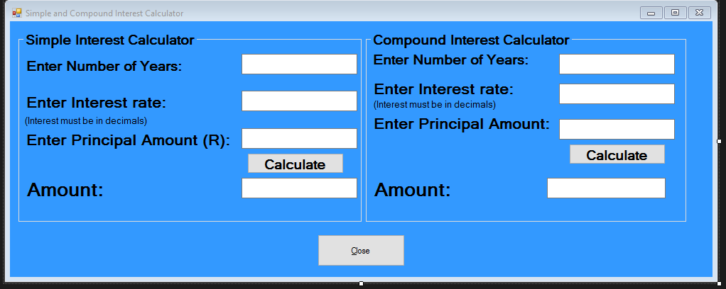

*Simple and compound interest code*

using System;

using System.Collections.Generic;

using System.Linq;

using System.Text;

using System.Threading.Tasks;

namespace WindowsFormsApplication1

{

class CInterest

{

private double principalamount;

private double numberofyears;

private double interestrate;

public CInterest()

{

}

public double CompoundInterestFormula()

{

double pa = principalamount;

double noy = numberofyears;

double ir = interestrate;

double result = pa * (1 + ir*noy)*(1 + ir*noy);

return result;

}

public double SimpleInterestFormula(double pa, double noy, double ir)

{

//pa = principalamount;

//noy = numberofyears;

//ir = interestrate;

double result = pa*(1 + ir /100* noy);

return result;

}

}

}

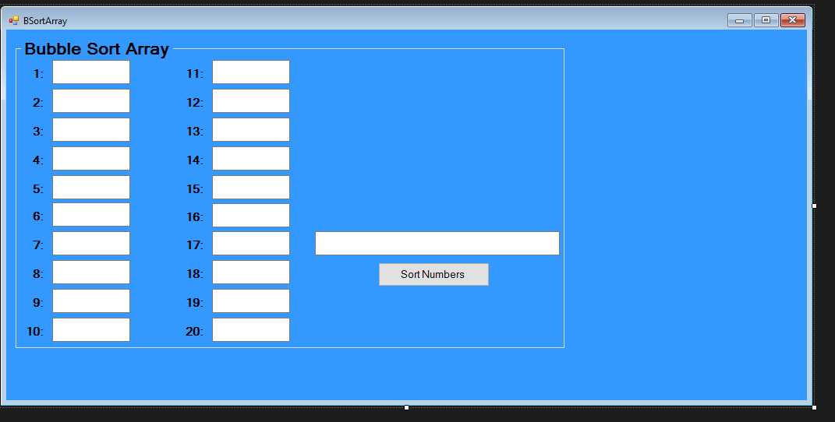

*Bubble sort Array code*

using System;

using System.Collections.Generic;

using System.Linq;

using System.Text;

using System.Threading.Tasks;

namespace WindowsFormsApplication1

{

class BubbleSortArray

{

//Defining the data fields for the array

// public static int num1;

//public static int num2;

//public static int num3;

//public static int num4;

//public static int num5;

//public static int num6;

// public static int num7;

// public static int num8;

// public static int num9;

// public static int num10;

//public static int num11;

//public static int num12;

// public static int num13;

//public static int num14;

// public static int num15;

//public static int num16;

//public static int num17;

//public static int num18;

//public static int num19;

//public static int num20;

//Defining an array

public void Bsort(int num1, int num2, int num3, int num4, int num5, int num6, int num7, int num8, int num9, int num10, int num11, int num12, int num13, int num14, int num15, int num16, int num17, int num18, int num19, int num20)

{

int[] bubblesort = { num1, num2, num3, num4, num5, num6, num7, num8, num9, num10, num11, num12, num13, num14, num15, num16, num17, num18, num19, num20 };

int jerr;

for (int i = 0; i <=bubblesort.Length-2; i++)

{

for (int j = 0; j <=bubblesort.Length-2; j++)

{

if (bubblesort[i]>bubblesort[i+1])

{

jerr = bubblesort[i + 1];

bubblesort[i + 1] = bubblesort[i];

bubblesort[i] = jerr;

}

}

}

//foreach (int ff in bubblesort)

//{

//}

}

}

}